**Investigation of Semi-persistent scheduling for an intersection scenario**

Abstract

*The Cellular vehicle-to-everything (C-V2X) network is a significant vehicular communication technology to enable reliable safety applications and services for the vehicles. Besides the other decisive factors such as periodic status updates, the successful rate of the communication is also an important factor of the communication quality (i.e., packet receive rate (PRR)). In this context, we apply the semi-persistent scheduling (SPS) (which is the base of the C-V2X transmission mode 4) under different scenarios of the vehicle communications to study the effect of the different parameters on the performance of semi-persistent scheduling. Specifically, we varied the density of the vehicles, the available communication resources of the vehicles and the distance of the obstacle from the road which is used to simulate the possible blockage that happens in the reality. We also tried to depict the graph of the PRR of the cars. Our result shows that the performance of one shot SPS is largely affected by the density of cars, and is also influenced by the available communication resources of the vehicles and the distance of the obstacle from the road.*

**Introduction**

The new generation of automated vehicles should be able to gather information from the surroundings, especially other vehicles to reduce the possibility of causing accident. The efficient data exchange needs to have the properties such as high through put, low latency and high reliability [3].

To this end, vehicle-to-everything (V2X), which is a vehicular communication technology enabling vehicles to exchange data with its surrounding is proposed [2]. There have been several proposals (i.e., the dedicated-short-range communications and the Intelligent Transportation System) [6]. Although they can meet the basic requirement of the vehicular communication, a new standard called the cellular-vehicle-to-everything (C-V2X) was introduced by the 3rd Generation Partnership Project (3GPP) in release 14 and 15 [2,7] in 2017. C-V2X includes 4 specific applications: vehicle-to-vehicle (V2V), vehicle-to-infrastructure (V2I), vehicle-to-pedestrian (V2P) and vehicle-to-network (V2N), which is introduced by the 3GPP [4]. C-V2X meets the requirement of low-latency and it is also able to maintain a high transmission speed in a limited range of vehicle density [1].

C-V2X is based on the LTE sideline which has 4 working modes. The mode 1 and mode 2 are defined for the device-to-device (D2D) communication [5]. The D2D create short link between the nodes to enable the quick exchange of data. The mode 3 and mode 4 are defined for the vehicle-to-vehicle (V2V) communication, which are used for the C-V2X. Compared to Mode 1 and mode 2, Mode 3 and Mode 4 possess a lower latency. In mode 3, there will be a base station to handle the allocation of the communication resources. In mode 4, however, the vehicles assign and manage their communication resource by themselves, without any support of the infrastructure [5]. Therefore, the semi-persistent scheduling (SPS) is used, which is a protocol vehicles use to select their communication resources without any assistance of the infrastructure for Mode 4.

The basic mechanism of the SPS is that vehicles hold their current communication resources for a random period of time. When the time runs out, the vehicles randomly choose from the resources which are least interfered with a uniform probability. If the communication resource is chosen by a vehicle, it may be kept by the vehicle after the time runs out, but the vehicle may also re-select a new communication resource [8].

Although SPS satisfies the requirement of low latency for C-V2X, C-V2X cannot maintain the high reliability of communication when the vehicle density goes up. We explore the influence of different parameters on SPS to figure out how to maintain a high communication quality using C-V2X.

This report will focus on mode 4 of C-V2X. Specifically, we will evaluate the performance of SPS under different scenarios to determine factors which have influence on the transmission quality. We performed simulations using a Python program designed to model the mechanism of the SPS process of C-V2X mode 4, which is introduced in detail in [7]. We change the parameters (i.e., vehicle density, the hearing range of vehicle, the distance of the obstacle) and evaluate the performance of SPS in these different scenarios in terms of PRR.

The numerical results show that the number of the communication resources, the distance of the obstacle and the density of the vehicle all have influence of the performance of the SPS in different scales. Specifically, the high vehicle density will severely influence the communication quality of the SPS , the higher the density, the worse the communication quality(i.e. lower PRR values). Our results show that the distance of the obstacle also has an influence on the performance of SPS, the bigger the distance of the obstacle from the road, the worse the performance of the SPS. Moreover, the result shows that if the amount of transmissions is larger than the limit of the communication resources, the performance of SPS will decrease.

**Method**

We used Python to simulate the V2V communication scenario using C-V2X for basic safety message(BSM) transmissions.

The basic setting of the scenario is that the cars are evenly distributed on two crossing roads, and the vehicles have a limit called the hearing range. When the transmission between the vehicles happens, the vehicles only can reach the cars within its hearing range, which is shown in Fig.1

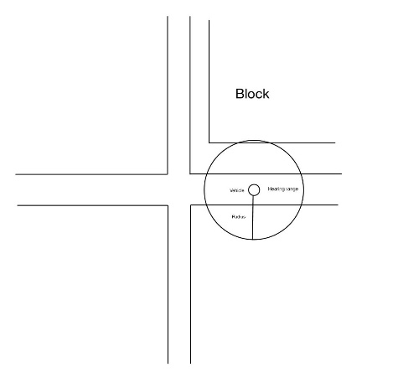

Fig.1: The vehicle on a crossroad with building block.

In the simulator, we define a class to store information for each vehicle. It has multiple properties which is essential for the communication between the cars, i.e., the position of the vehicle on the road, the total communication resources, the timer, the hearing range and the resources that the vehicles are currently occupying.

In this simulation scenario, all the vehicles attempt to transmit messages to other vehicles simultaneously. The physical communication resource is divided using Orthogonal Frequency-Division Multiple Access (OFDMA). OFDMA divides the physical channel in both the time domain and the frequency domain. In time domain, the OFDMA divides the physical channel into sub-frames. In frequency domain, the OFDMA divides the physical channel into sub-channels. In our setting, the physical channel is divided into 20 sub-frames and 5 sub-channels. The communication resource in our simulation is modeled by a fixed size array in Python.

However, when the messages are transmitted to the target vehicle, they will suffer attenuation. In our scenario, we assume that the attenuation of the signal power is the square of the distance. The received power *Pr* of the target vehicle which is *d* m away from the transmitting vehicle with transmitting power *Pt* is given by:

 (1)

Additionally, the message of the transmitting vehicle will be interfered by the message of the other vehicles within the hearing range of the target vehicles using the same resources.

There will also be channel noise in the communication process. Here, we use white noise to model the channel noise.

To determine whether the transmission success or not, we use the signal-to-interference-plus-noise ratio (SINR) whose definition is the power of the wanted signal *Pw* compared to the interference power *Pi* and the power of the noise *Pn*, which is given by

 (2)

If the SINR is larger or equal than 1, then we consider it a successful transmission, otherwise, the transmission fails and the receiving vehicle cannot obtain the information it required from the other car.

The communication quality is evaluated by the PRR and the collision rate (CR), which is shown in the formulas (3) and (4).

 (3)

 (4)

Besides, the number of success transmissions plus the number of collision should be equal to the total number of transmission. Therefore, the change of the PRR and the CR should be balanced out.

**SPS**

The SPS is the foundation of C-V2X mode 4. It is a mechanism that enables the vehicles to choose communication resources autonomously, without the assistance from the infrastructure.

The vehicles in this mode randomly select a resource from the candidate list. However, there is certain requirement to be selected in the candidate list. The communication resources are sorted according to the reference signal resource power (RSRP). If the RSRP of communication resources are larger than the given threshold, then they are excluded from the candidate list. Otherwise, they are in the candidate list. Besides, the size of the candidate list should not be smaller than the 20% of the total number of the communication resources. If the size of the list does not meet the standard, the vehicle will keep increasing the threshold by 3dB until the size of the list is not smaller than the 20% of the communication resources. In our simulation, however, we did not set a given threshold. Instead, we first sort all the communication resources according to their RSRP, then we choose the communication resources whose RSRP are the lowest 20%.

Once a vehicle selects a new communication resource, it keeps transmitting messages to other vehicles using this resource for next communication *Cc* time frames. Here the *Cc* is defined as counter whose value is chosen randomly from a given interval [*α*，*β*] with 0 < *α* < *β* and the *α*，*β* are fixed integers*.* When the timer *Cc* is not zero, the timer *Cc* is reduced by 1 after each transmission. When the *Cc* goes to zero, the vehicle re-select a communication resource from the candidate list with probability *Ps* and the vehicle may also keep its current communication resource by the probability of *Pk* = 1-*Ps*. The timer *Cc* is reset to a random number no matter whether the vehicles select the new resource or not. In our setting, the vehicles are set to select new communication resource with probability 1.

**RESULT ANALYSIS**

In this section, we will analyze the simulation results of different scenarios. All the simulation are executed based on the scenario of a cross road. The cars are recognized as dots in this simulation. Each car is able to transmit and receive the signal power, and they are evenly distributed on a crossroad (half on the horizontal road and half on the vertical road).First, to test whether the SPS is effective in our simulation, we run a test and the parameters of the simulation is shown in the Table. 1:

|  |  |
| --- | --- |
| Number or transmitting cars | 100 |
| Time interval | 1000 |
| Number of communication resource | 100 |
| Hearing range of vehicles | 3500m |
| Noise power | 0.1/16000000 w |
| Transmitting power | 0.1 w |
| Distance of the obstacle from the road | 600m |
| Length of the road | 10000m |

**Table 1**: The parameter for SPS test.

We used the average of the PRR and CR of all the vehicles in a single time frame to depict the quality of the communication.The result of the test is shown in Fig.2(a) and Fig.2(b). respectively, which are shown below:

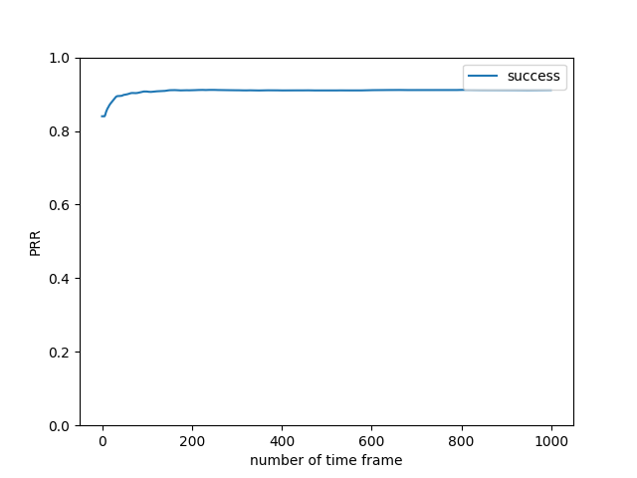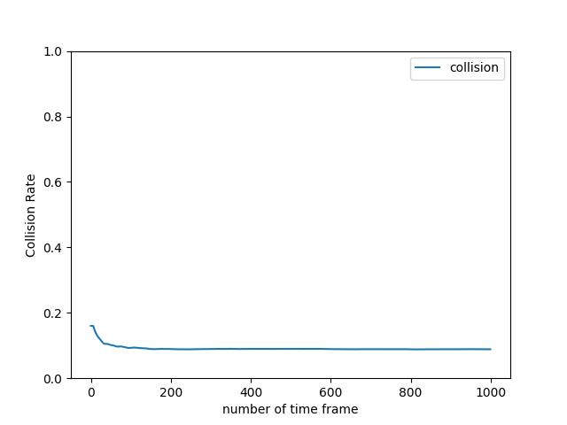

Fig.2(a) average PRR Fig.2(b) average CR

The results of the test show that there is a decrease in CR and an increase in PRR as the simulation proceeds, which indicates the adaptive mechanism inherent in the SPS protocol. Specifically, the PRR increases from 84% to 91% which indicates a 10% increase in the PRR and the CR decreases from 16% to 8% which means a 50% decrease in the CR, which indicates that the enhancement of the performance of the SPS as the communication process proceeds.

1. **Vehicle density and number of resources**

In this section, the effect that the vehicle density have on the performance of the SPS will be illustrated and analyzed.

We simulated several scenarios to study the relationship between the vehicle density and the performance of the SPS. In these scenarios, the amount of communication resources is constant, and the amount of the vehicles is varied in a certain range. Therefore, we used the average PRR of all the vehicles in the time frame to convey the performance of SPS of a certain amount of vehicles. The fundamental parameters of the simulation is shown in Table. 2

|  |  |
| --- | --- |
| Time interval | 1000 |
| Number of communication resource | 100 |
| Hearing range of vehicles | 2500m |
| Noise power | 0.1/6250000 w |
| Transmitting power | 0.1 w |
| Distance of the obstacle from the road | 0m |
| Length of the road | 10000m |
| SINR threshold | 1 |

**Table 2**: The parameter for vehicle density test.

The number of the vehicles are varied from 100 to 350. The simulation result is shown in Fig.3

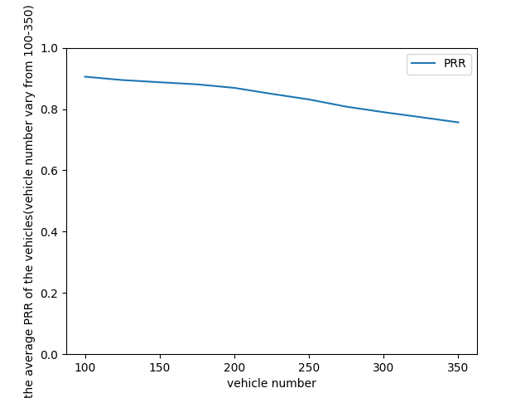

Fig.3 The average PRR of all the vehicles

The result above reveals that as the number of the vehicles increases, the average PRR experiences a general decline. When the vehicle number reaches 350, the average PRR is approximately 60%, approximately more than 10% lower than that of the situation which the vehicles number is 100. The result also indicates that there is a break point in the graph when the vehicle number is 200, after which the PRR drops faster. According to the simulation setting, the maximum number of vehicles that a single vehicle can reach is half of the total number of vehicles. When the car number reaches 200, there are 100 vehicles on the horizontal road and vertical road respectively and 100 is also the amount of the communication resource. Thus, to further verify the factor that cause the break point, we change the number of the communication resource from 100 to 125 and run the simulation again, the result is shown in Fig.4

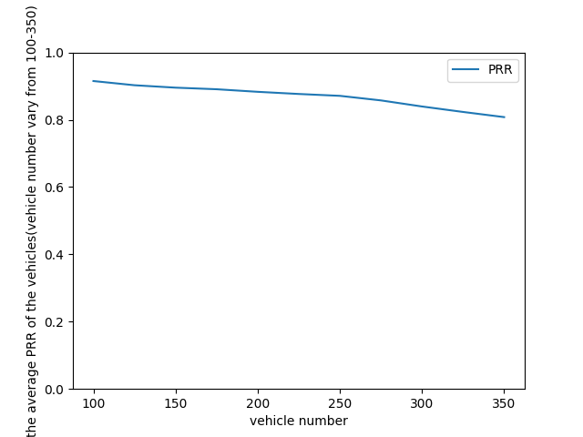

Fig.4 The average PRR of all the vehicles

The result above shows that the break point shifts backward to the point which the vehicle number is 250. The phenomenon is corresponding to the assumption that the performance of the SPS is also restricted by the communication resource.

To further illustrate the impact that the vehicle density has on the performance of the SPS, a simulation scenario is created which attempts to depicts the result of the vehicle density (which is referred to as the amount of the vehicles in the intersection that the vehicles can reach) on the different position of the road and the average PRR of the vehicles on the road. In the simulation setting, the fundamental parameters of the scenario is already shown in Table.1. The results are shown in Fig.5:

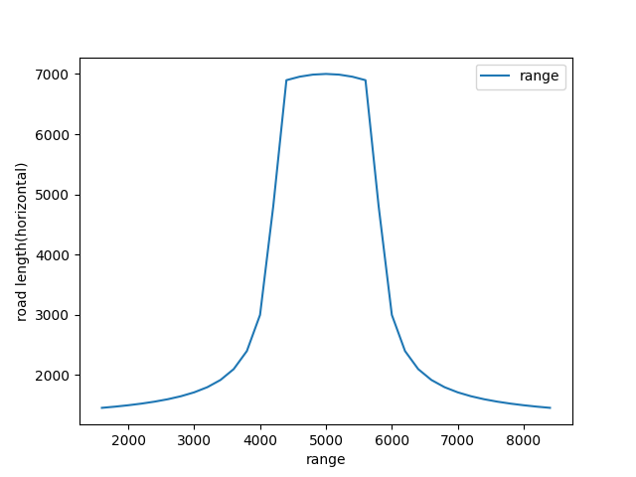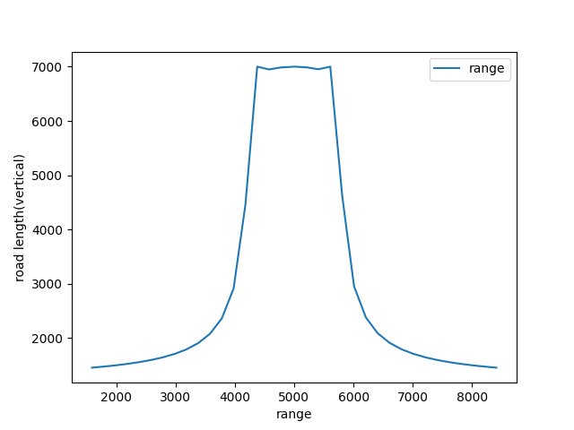

Fig.5(a) the reachable length of the road(horizontal) Fig.5(b) the reachable length of the road(vertical)

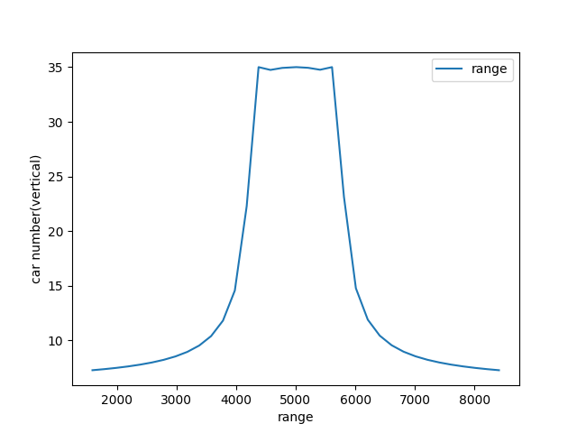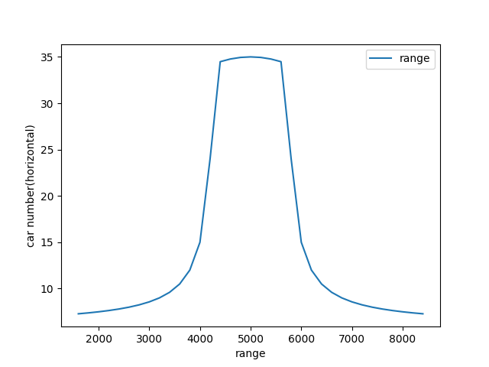

Fig.5(c) the reachable car number of the road(horizontal) Fig.5(d) the reachable car number of the road(vertical)

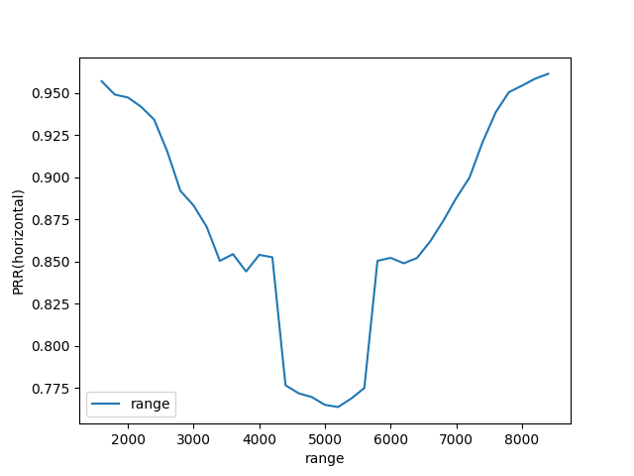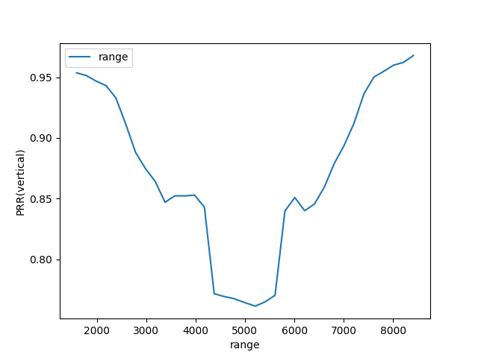

Fig.5(e) the corresponding PRR of the vehicle(horizontal) Fig.5(f) the corresponding PRR of the vehicle(vertical)

The results above showed that the reachable car number on the road increases as the distance from the intersection decreases, which indicates that the vehicle density reaches the peak at the intersection of the road, and gradually decreases towards the edge of the crossroad. On the contrary, the PRR of the vehicles in the intersection is significantly lower than that of the vehicles that are far away from the intersection. Specifically, the value of the PRR on the edge of the road is higher than 95%, however the value of the PRR on the edge of the road is higher than 77.5% which drops approximately 19%.

These results underscore the impact of vehicle density and the resource constraints on performance of the SPS in vehicular networks, providing valuable insights for designing and optimizing communication protocols in densely populated environments.

1. **Distance of the obstacle**

Besides the vehicle density, the distance of the obstacle may also affect the communication quality. We simulated two scenario to study this. The obstacle exists in one scenario but does not exist in the other scenario. The parameters of the simulation (except the distance of the obstacle) is shown in Table.4

To make the comparison of the result from two scenarios brief and clear, we use the average PRR of the horizontal road to illustrate the communication quality, the result is shown in the Fig.6

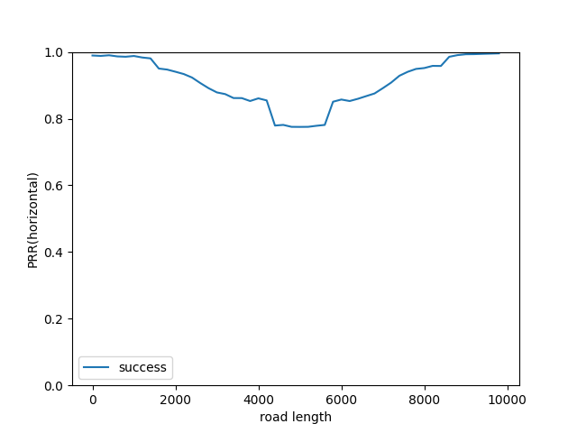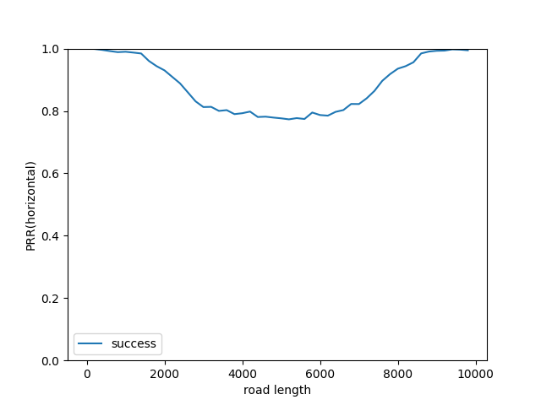

Fig.6(a) average PRR of the vehicle(with obstacle) Fig.6(b) average PRR of the vehicle(without obstacle)

The result above showed that the value of average PRR of the vehicles in the scenario where the obstacle exists are generally higher than that of the vehicles in the other scenario. The average PRR of vehicles in the two scenarios is only approximately equal to each other when there is no obstacle blocking the transmission. Based on this result, the assumption can be made that although the existence of the obstacle block the transmission, it still generally improves the performance of the SPS by reducing the number of vehicles that a transmitting vehicle can reach.

To further study this assumption, another scenario is created. The parameters are shown in Table.4

|  |  |
| --- | --- |
| Number or transmitting cars | 100 |
| Time interval | 1000 |
| Number of communication resource | 100 |
| Hearing range of vehicles | 7000m |
| Noise power | 0.1/49000000 w |
| Transmitting power | 0.1 w |
| Length of the road | 10000m |

Table.4 The setting of the scenario

In this scenario, the distance between the obstacle and the road is varied from 1000m to 2500m and the average PRR of all the vehicles which have distance of 2000m-3000m away from the intersection is used because this parameter is largely affected by the blockage of the obstacle. The result is shown in Fig.7.

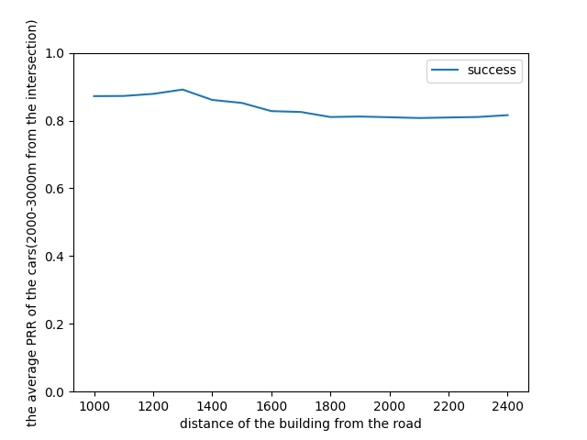

Fig.7 The average PRR of the vehicles(2000m-3000m from the intersection)

The results above indicates that the average PRR of the vehicles generally decreases as the distance between obstacle and the road increases. Specifically, there is a more than 10% decrease from the peak of the PRR to the point which the PRR reaches its lowest value, which is about 80%.

This again illustrates that the existence of obstacle partly increases the performance of the SPS by limiting the number of vehicles that the transmitting vehicles can reach.

**Conclusion**

This paper investigates the impact of different parameters have on the performance of SPS in V2X networks. In particular, we developed a simulator and used it to study changes in the vehicle density, the available communication resources and the distance of the obstacles from the road. All of the results are evaluated using the average PRR of the vehicles in each setting. The results showed that the performance of SPS is strictly limited by the number of the available communication resources. If the available communication resources cannot accommodate the load of the transmission, the performance of SPS will decrease significantly. Similarly, the impact of vehicle density on communication quality is explored, with the results indicating a negative correlation between the vehicle density and the communication quality. As the vehicle density increases, the performance of the SPS severely decreases. The results also reveals that the blockage from the obstacle improves the performance [1]of the SPS generally, by reducing the load of the transmission, which is implemented by limiting the number of vehicles that the transmitting vehicle can reach.

**References**

[1] A. Nabil, K. Kaur, C. Dietrich and V. Marojevic, "Performance Analysis of Sensing-Based Semi-Persistent Scheduling in C-V2X Networks," 2018 IEEE 88th Vehicular Technology Conference (VTC-Fall), Chicago, IL, USA, 2018, pp. 1-5, doi: 10.1109/VTCFall.2018.8690600.

[2] K. Sehla, T. M. T. Nguyen, G. Pujolle and P. B. Velloso, "Resource Allocation Modes in C-V2X: From LTE-V2X to 5G-V2X," in IEEE Internet of Things Journal, vol. 9, no. 11, pp. 8291-8314, 1 June1, 2022, doi: 10.1109/JIOT.2022.3159591.

[3] M. M. Saad, M. T. R. Khan, S. H. A. Shah and D. Kim, "Advancements in Vehicular Communication Technologies: C-V2X and NR-V2X Comparison," in IEEE Communications Magazine, vol. 59, no. 8, pp. 107-113, August 2021, doi: 10.1109/MCOM.101.2100119.

[4] F. Eckermann, M. Kahlert and C. Wietfeld, "Performance Analysis of C-V2X Mode 4 Communication Introducing an Open-Source C-V2X Simulator," 2019 IEEE 90th Vehicular Technology Conference (VTC2019-Fall), Honolulu, HI, USA, 2019, pp. 1-5, doi: 10.1109/VTCFall.2019.8891534.

[5] M. Gonzalez-Martín, M. Sepulcre, R. Molina-Masegosa and J. Gozalvez, "Analytical Models of the Performance of C-V2X Mode 4 Vehicular Communications," in IEEE Transactions on Vehicular Technology, vol. 68, no. 2, pp. 1155-1166, Feb. 2019, doi: 10.1109/TVT.2018.2888704.

[6]V. Mannoni, V. Berg, S. Sesia and E. Perraud, "A Comparison of the V2X Communication Systems: ITS-G5 and C-V2X," 2019 IEEE 89th Vehicular Technology Conference (VTC2019-Spring), Kuala Lumpur, Malaysia, 2019, pp. 1-5, doi: 10.1109/VTCSpring.2019.8746562. keywords: {Physical layer;Throughput;Encoding;Signal to noise ratio;Bandwidth;Gain;Communication systems},

[7]A. Fouda, R. Berry and I. Vukovic, "Interleaved One-shot Semi-Persistent Scheduling for BSM Transmissions in C-V2X Networks," 2021 IEEE Vehicular Networking Conference (VNC), Ulm, Germany, 2021, pp. 143-150, doi: 10.1109/VNC52810.2021.9644679.

[8]A. Bazzi, C. Campolo, A. Molinaro, A. O. Berthet, B. M. Masini and A. Zanella, "On Wireless Blind Spots in the C-V2X Sidelink," in IEEE Transactions on Vehicular Technology, vol. 69, no. 8, pp. 9239-9243, Aug. 2020, doi: 10.1109/TVT.2020.3001074.

1. This research is conducted together with Ruiqi Cai. Different from his result, the result of mine is based on the SPS which has the resources sorting algorithm.